## Data Visualization: Resistance/Support levels

#### **Introduction**

Data visualizations are simplifications of complex relationships that enable the user to see and understand trends, outliers, and patterns in the data.

Financial and Crypto markets are complex. A common concept used for analyzing financial markets are resistance and support levels (you can read more about it [here](https://www.investopedia.com/trading/support-and-resistance-basics/)).

In the chart below you have a static view on the price of BTC in USD over a 28d period and the **sumtotal** of the on-chain transfer volumes compared to off-chain transaction volumes on exchanges during the same time period.[1]

Are the larger bars in proximity to local extrema of the price series as the theory would suggest? (this is a rhetorical question, but worthwhile to check when plotting data)

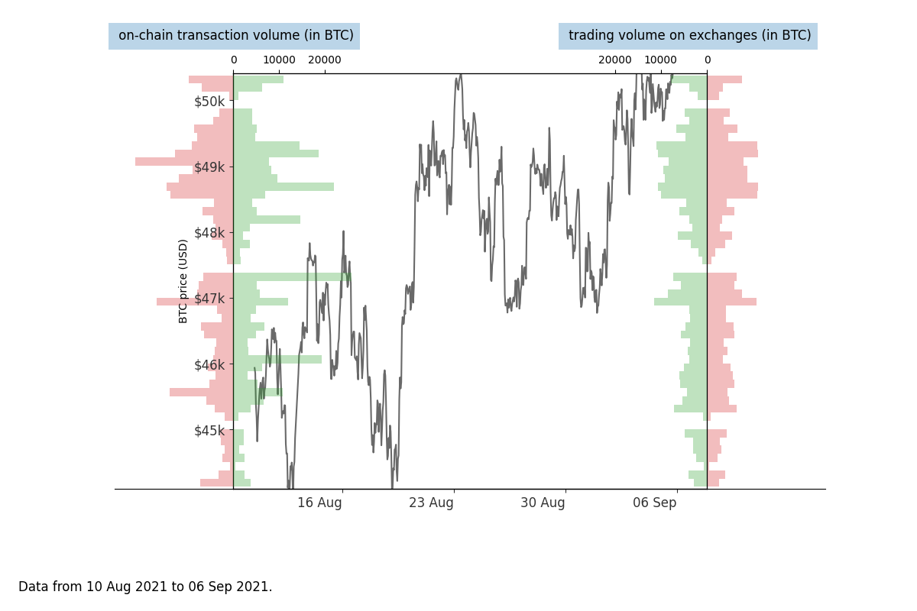

#### **Task**

We are providing .csv files for the task, descriptions below. The solution provided will solely be used to assess your analytical and visualization skills and your solution will be part of a follow-up interview.

We ask you to…

* Create a data visualization that allows a user to explore potential support and resistance levels[2]
* Make it
  1. dynamic: display relevant information on hovering and
  2. interactive: have at least 1 control element like a radio-button, drop-down, time-slider, button, etc. that changes the context
* Document your thought process, analysis and data manipulation that led to the solution (e.g. .ipynb)
* Provide short answers to the following questions:
* From a user’s point of view, what interesting relationship could you find in the data?
* How would you guide a user to interesting bits of information?
* What question or task would you have addressed next if you had more time?

#### **Data**

The following data files are provided (covering 8 October - 19 November 2021)

* on_chain_ETH_BTC.csv[3]:

ts, # date

metric, # direction, to or from exchange

asset, # BTC or ETH

currency, # quote currency: USD

value # transfer value in USD

* buy_sell_volume_BTC.csv, buy_sell_volume_ETH.csv[4]:

time_executed, # date

volume_buy, # buy volume filled, denominated in #BTC or #ETH)

volume_sell, # sell volume filled, in #BTC or #ETH)

trades_buy, # number of trades, buy

trades_sell # number of trades, sell

* price_BTC.csv, price_ETH.csv:

time_open, # date

close # closing price, end of day

* orderbook.csv (**only available for BTC**):

date, # daily

price, # order price levels per day

quantity # size of orderbook within price bracket

#### **What we are looking for**

* Clean, executable code, documenting the thought process and analysis
* An interactive visualization (share a link to a hosted solution, a locally working version)
* Short answers to the questions

1. On-chain vs. off-chain would be analogous to a physical goods’ market (like gold). The bars on the left represent the amount of gold trucks moving BETWEEN different market places, while the right bars represent how much gold is exchanged WITHIN a marketplace. The left pyramid, shows transfers to [=green] and from [=red] exchanges compared to off-chain transaction volumes on exchanges during the same time period: trade execution at buy limit=green, trade execution at sell limit=red.
2. Note: don’t get hung up on the plot provided, there might be better ways of comparing on- and off-chain movements in relation to price.
3. See <https://docs.glassnode.com/api/transactions#transfers_volume_to_exchanges_sum> and <https://docs.glassnode.com/api/transactions#transfers_volume_from_exchanges_sum>
4. _buy and _sell mean execution of limit orders from the point of view of the market maker. The total volume transacted in the time frame is the sumtotal of those 2 values. In periods of sharp price movements there will be an imbalance, but typically the volumes are close for hourly aggregates

   The volumes from this source are denominated in BTC and ETH (convert to USD!)